## Coal Worksheet

1. How were the trees that existed at the time the US’ coal deposits were forming, different than most trees today?

* Tall with shallow roots
* Would routinely fall

1. What is an important reason that in this early time in Earth history (the Carboniferous Period), such vast and rich coal deposits were able to form? (in what important way was Earth different than it is today that allowed this to occur?)

* Bacteria had largely been yet to evolve to be able to eat wood
* Fallen wood would continue to compress each other into the ground

1. Why is coal used so widely as a fossil fuel? (i.e. what advantages does it have over other energy sources)

* Far more efficient than other fossil fuels

1. What percentage of the world’s coal reserves are in the United States?

* 25%

1. What are a few drawbacks to using coal as an energy source? (i.e. what disadvantages does it have over other energy sources?)

* Imposed significant environmental costs

1. According to the World Energy Council, coal use is expected to rise by 60% by 2030. What percentage of this increase are developing countries expected to be responsible for?

* 97%

1. In your own words, summarize how coal is formed (rephrasing in your own words in important)
2. Plant matter falls on ground in significant quantity
3. Forms into peat
4. Layers of beat get buried and collect underground
5. Get squeezed from high pressure, releasing its water
6. Heat bakes it, forming coal
7. What were the major coal forming time periods (list name of period and time range) responsible for forming the coal within the US, and where are the deposits from each time period located?

* Pennsylvanian
  + 318-299 million years ago
  + Appalachian
* Cretaceous
  + 145-65 million years ago
  + Colorado, Utah, and New Mexico
* Tertiary
  + 65-35 million years ago
  + Wyoming, Montana, North Dakota, and Texas.

1. How were those three regions of the US different at the time coal was forming that they are today?

* Contained large inland seas and lakes surrounded by warm, swampy coastal plains filled with decaying plants

1. Name one modern example of a place on Earth where peat is being formed (which could become coal if buried)

* Indonesia

1. How are the coal deposits east of the Mississippi different from the coal deposits west of the Mississippi?

* Coal east of the Mississippi is primarily a dense, high grade of coal, called bituminous, that contains up to 85 percent carbon
* Western coal is younger and a different kind of coal altogether. It’s a much softer version, called sub-bituminous coal, that contains less than 45 percent carbon.

1. Given current trends of consumption, how long until we exhaust the coal deposits in the US?

* Article says “we’ll” run out in 225 years – unsure if that’s nationally or globally

Coal

Organic sedimentary rock formed from plant remains deposited in swamps and marshes

* Composed of carbon, hydrogen, oxygen, nitrogen

Major use is generating electric power

* 25% of total energy consumption in US
* 52% of electricity generation in US fueled by coal
* 560 coal plants in US
* One of the largest sources of CO2, gas largely responsible for climate change

Composed of organic matter that has escaped oxidation in the carbon cycle

* Plans grew and died in soggy areas, piled up and compressed to peat
* Heat and pressure releases volatiles (oxygen and hydrogen), concentrating the carbon
  + 10 feet of peat -> 1 foot of coal
* Why do we know this?
  + Coal beds often adjacent to shale beads and limestone beds

Ranks (low to high), in order of increasing pressure, temp, and depth of burial

1. Peat: Sediment that forms coal
   * Brown, partially decayed plant fragments
   * Used for fuel in some regions
   * Not usually considered renewable (slow renewable)
2. Lignite: Soft, dark grown / gay, crumbly, sooty coal
   * Plants may be visible
   * Formed from compacted peat under low pressure and temps
   * Carbon content: 46-60%
3. Sub-bituminous: Intermediate between lignite and bituminous coal
   * Carbon content: 46-60%
4. Bituminous: Most abundant coal in US
   * Hard, but slightly sooty coal
   * Dull to shiny luster
   * May have layers
   * Deeper, longer burial and higher temperatures
   * 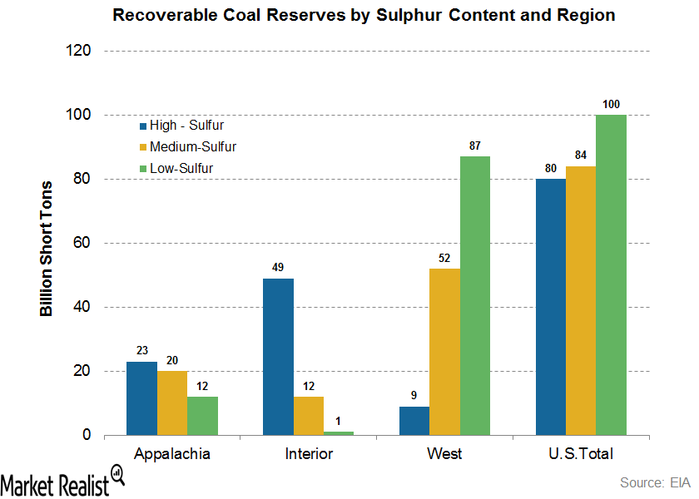Carbon content: 46-86%
5. Anthracite coal: Highest coal rank
   * Hard, shiny with silvery luster
   * Metamorphic rock formed from bituminous at high temps and pressures
   * Carbon content: 86-98%

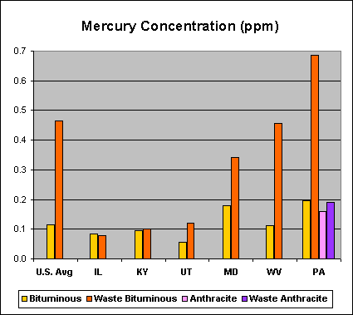Sulfur in coal

* Most important component within the regulatory environment

Mercury in coal

* Different coals contain different levels of mercury
* Eastern coals have most, particularly PA

Eastern vs Western Coal

* Eastern: Higher rank, higher sulfur, higher mercury, deeper seams
* 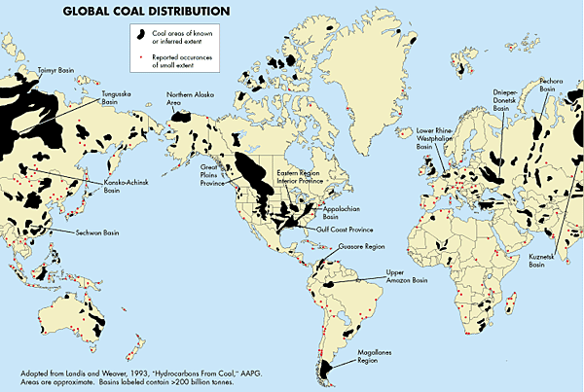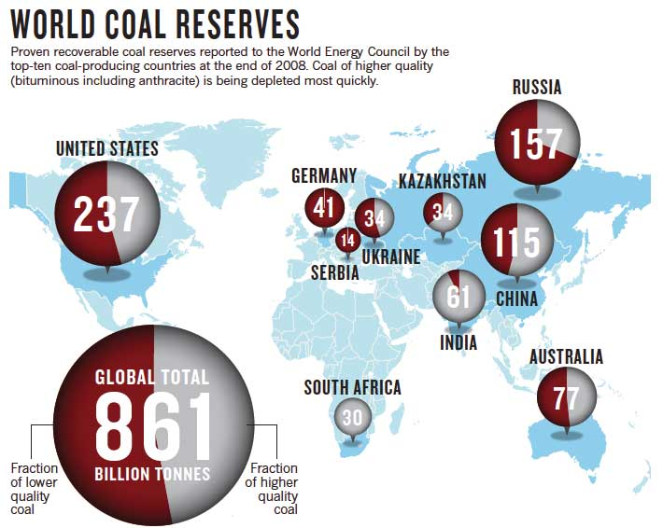Western: Higher rank, lower sulfur, higher mercury, shallower seams

Global distribution:

* More evenly distributed than petroleum

Future of coal:

* Due to large deposites, low cost, and high demand, coal will be mined for long time
* China, US, and Russia account for half of CO2 released into atmosphere
  + Largely from coal
  + Growth in use expected to continue
  + China projected to account for 85% of coal use growth

Unpaid externalities

* Release of mercury, CO2, and other toxic components represent a toll on the environment and health not accounted for in their market price
* If the cost of these pollutants were internalized, their capital and operating costs would increase, making coal less competitive

Ash removal

* Sophisticated tech used to remove ash particles from emissions
  + 21st century tech to clean as out of air
  + 13th century tech to flush it into a big hole in the ground
* Water used to flush ash into nearby hole
  + Usually unlined pits
  + Arsenic and mercury
* Old facilities often…
  + Separated from waterways by earthen dams
  + Beneath water table
  + Illegal!
    - Clean Water Act, 1972
    - Water pollution through dikes into rivers
    - Seeping into ground water
* Case studies:
  + Ash Pond on Wateree River, near Columbia, SC
    - 3 miles north of Congaree National Park
    - Wateree Riverkeeps (citizen group) worked out settlement to remove ash
  + NC
    - SELC sent noticeses that Duke Energy breaking law at multiple cites
      * Duke claims theyre using the best technology, its fine, citizen groups should be stopped
      * Moved to get state to block law enforcement
    - Dan River site fails
      * Duke pleads guilty 18 tyimes to 9 crimes at 5 sites across NC

Environmental laws

* Congress overrode Nixon veto of Clean Water Act
* State enforcement of these laws limited
  + Agencies dependent on state legislature to fund them
* Utility lobbying is significant in state legislatures
  + Legal monopolies
  + Tremendous resources in lobbying and lawyers

Oil and Natural Gas

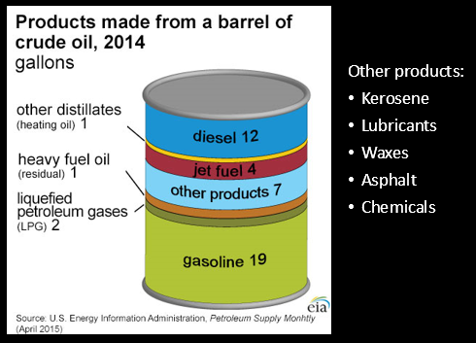

Oil

* Liquid hydrocarbons that are present in layers of sedimentary rock
  + Geosphere
* Petroleum can be extracted and refined into fuels and chemicals
* Formed in subsiding, depositional marine basins
  + Sediments continually buried by younger sediments
  + Continues until material subjected to high temps and pressure
* Only formed by thermogenic transformation of marine organic matter

Natural Gas

* Major component is methane, CH4 – also includes ethane, propane, and butane
* Can be formed by thermogenic reactions at depth
* Or by biogenic processes near surface (eg: methane forms in landfills)

Formed by plankton

* Rich in lipids
* Trapped in marine sediment
* When buried, transforms into oil and natural gas after millions of years of heat and pressure

Source rocks

* Impermeable shales containing deal plankton which escaped decay on seafloor
* After petroleum formation, hydrocarbons upwardly migrate out of source rock with more porosity and permeability

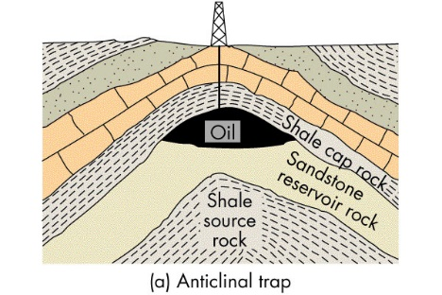Reservoir rocks

* More permeable formations like sandstones
* Must be trapped in subsurface beneath impermeable cap rocks
  + Anticlinal folds
  + 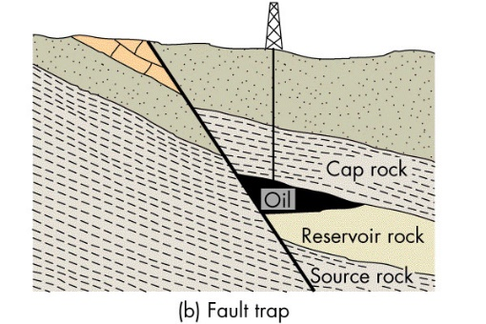Faults
    - Fracture or bedding plane can allow oil to get to surface,
      * Oil seeps
  + 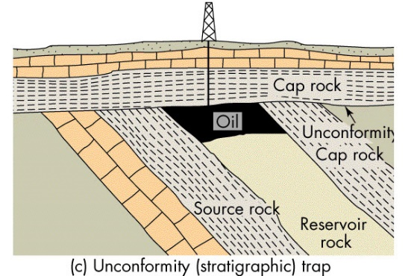Unconformity

Oil recovery rates

* Primary: Traditional oil wells
  + 35%
* Secondary: Steam injection
  + 10-25% more, but takes energy to get it
  + Also used to clean up ground water pollution

Global oil reserves and production patterns

* Produced out of sedimentary rocks deposited during last 500m years
* Most located near plate junctions active in last 60-70m years
  + Middle East is a triple plate junction, has been plate boundary for a long time – 66% of reserves

Hubbert Curve

* Oil geologist Marion King Hubbert predicted in 1956 that US production would peak in 1970
  + Oil reserve availability expressed through a normal curve
  + Largely correct!
* Global production would peak around turn of century
  + While logical, affectively wrong
  + IAE thinks won’t occur until 2030

Imported oil

* Majority of US oil consumption
  + Persian gulf, Mexico, Canada, Venezuela, Africa

Effect of rising prices – new reserves

* Becomes economically possible to extract from depleted reservoirs
  + Using secondary techniques
  + Drives technology
* Conventional reserves in remote areas become economic
* Other energy sources become more appealing

## Unconventional oil

Oil shale

* Fine grained sediment containing kerogen
* Oil has not yet migrated from source rock
* Very large deposits exist
  + 240x more shale oil than conventional oil
  + 89% of it in north america’s green river formation (Colorado, Utah, Wyoming)
* Rock extraction through mining, not pumping
  + Underground mining or strip-mined
  + Shale heated to 500C and enriched with hydrogen
    - Oil separated from waste material
* In situ methods
  + Shale fractured and ignited underground
  + Gases and oils collected at nearby well

Tar sands

* Combination of clay, water, and bitumen
  + Heavy, black viscous oil
* Mined and processed to extract bitumen
  + Refined into oil
* Bitumen cannot be pumped
  + Recovered through strip mining and in-situ methods
* Found all over world
  + 66% of world’s oil deposits
    - 34% in Venezuelan tar sands
    - 32% in Canadian tar sands (alberta)
      * 9% of US’s supply
      * Growing exports from increased production of tar sand crude
      * 20% recoverable by surface mining, 80% from in-situ tech
    - 33% in conventional oil

Environmental Impacts of Fossil Fuels

## Air Pollution

Natural or human-made

* Volcanoes, forest fires
* Fossil fuels

Clean Air Act

* Passed in 1963, strengthened in 1970
  + Tried to have been cut by Bush

Photochemical Smog

* Brown air smog
* Ample UV needed
* Automobile creates nitrous oxide
  + Combined with atmosphere’s oxygen to create yellow brown, photochemical smog
  + Reacts with UV to create Ozone
* Irritates lungs and lowers resistance to respiratory infections
  + May cause increased incidence of illness in children

Industrial air pollution

* Industrial smog:
  + CO2 (+ sulfur)
* Sulfur dioxide
* Sulfuric acid
* Gray-air smog

Inversion layers

* Subsidence inversion
  + Large mass of warm air moves into a region at high altitude, floats over a mass of colder air near ground
  + Prevents vertical mixing, keeping pollutants near ground
  + Common near LA
* Radiation temperature inversion
  + Typically at night – air near ground cools faster than air above it
  + In valleys
* Example: 1948
  + Smoke from Steel factories combined with temperature inversion
    - Turned flora barren, made driving difficult, homeowners had to repaint houses
    - Gave rise to environmental laws
  + Killed 20 and sickened 6,000
    - Previously considered little more than nuisance

Acid deposition

* Sulphur dioxide emitted into air and mixes with water to form acid rain
  + Can be transported long distances by wind before precipating
  + Affects freshwater lakes and wildlife, and damages acid-sensitive buildings
* Soil acidification
  + Can be buffered by CO3 soils like limestone
  + Areas with thin granitic soils sensitive
* Problems:
  + Respiratory diseases
  + Toxic metal leaching
  + Damage to structures
  + Decreased visibility
  + Decreased productivity

Health effects:

* Asthma
* Lung cancer
* Chronic bronchitis
* Emphysema
* Premature death

Mercury

* 48 tons from coal plants annually – 85% of the transmission of inorganic mercury to atmosphere
* Contributes to brain damage in children

# Global Warming

Surface temperature:

* The average temperature change across the globe is increasing about 1.25 degrees Celsius.
* The temperature has increased the most in Canada, north Africa, south South America, and Russia.
* However, temperature has declined in the north Atlantic. The places that have experienced the greatest warming are mostly continental settings.

Annual precipitation:

* The northern continents and South Africa that experienced the greatest temperature increase have also experienced a greater average annual precipitation.
* North Africa had a very decreased average rainfall.

Rate of Greenland Ice Loss

* From 2003-2006, ice loss was much less than in 2006-2012,
  + intact ice was increasing in the center of Greenland.
* Overall, from 2003-2012 there has been significant ice loss on the southern side of Greenland with no ice loss in the center.
* Greenland Jakobshavn Isbrae- largest outlet glacier (6.5% of Greenland’s Ice Sheet):
  + 1851-1964 .3 km a year,
  + stalls a few decades
  + 2001-present 3km per year. Increased rate of sea level rise by .06ml of sea level rise

Rate of Antarctic Ice Loss

* Overall gaining ice.
  + In the northern 90% it is gaining ice of about 1.5 cm/yr average and losing about 10 cm/yr in the north west peninsula (exposed to oceans).
  + The further north, the more ice is gaining.

Sea level change

* Sea level is rising at a linear rate with an average slope of 1.7 mm/yr from 1900-1980.
* However, the rate has recently almost doubled to a rate of 3.2 mm/yr.

Arctic sea ice

* :From 1984-2016 we have lost significant amounts of old ice (thickest ice).
* The more that old ice melts, the more seasonal ice there is each year.

CO2

* Since 1958, Atmospheric CO2 has increased from 320 to 400 parts per million.
* The concentration in Mauna Loa is increasing at a seemingly almost exponential rate based on the best fit line.

CO2, CH4, and N2O between 1750-2014:

* The greenhouses gases around 1900, all began to increase and in 1950 they all increased at very steep rates.

Solar radiation

* Solar radiation is reflected by atmosphere and surface. Absorbed by atmosphere, by surface, and re-emitted in the form of infrared radiation.
* Ways we can change surface temperature:
  + Change the amount of solar radiation
    - Sunspots : not associated with recent trends
  + Change distribution of solar radiation
    - Milankovitch cycles
      * The more tilt, more sunlight in polar regions – 41,000 years
      * The more eccentric, the more distance changes with sun – 100,000 years
      * The more processed, the more summer occurs close to sum – 23,000 years
    - Insolation: total sun power that reaches surface
      * Northern insulation decreasing despite global tempeature
  + Change the reflectivity of the planet (land surface) – albedo = heat reflected back to space
    - Decreased land and sea ice: lower albedo
    - Deforestation: higher albedo
    - Increased particulates: higher albedo
    - Increased cloud cover: higher albedo
  + Change how much radiation recycled by atmosphere
    - Greenhouse effect
      * Absorb radiation and re-emit in all directions
      * Water vapor, carbon dioxide, ozone, methane and nitrous oxide
    - Strong association with rising temps
* Paleoclimate
  + We can use ice cores to measure prehistoric climate trends
    - Current CO2 much higher than any time within past 800,000 years
  + Can use sediment cores to measure past 200m years
  + Glacial = cold period
    - Oceans have lots of heavy oxygen, ice has less heaxy oxygen
  + Interglacial = warm period
    - Oceans have lots of light oxygen
    - Ice has more heavy oxygen

Melting Permafrost

* Releases more Carbon and other nasty stuff

Changes in organism range

* Causes invasive species and pests

Ocean acidification

* Reefs die
* Shells disolve